Java and JavaFX Setup Verification
Name: Zachary White
Instructor: Darrell Payne
Date: August 16, 2026
Assignment: Module 1 Programming Assignment - Random Card Display (CSD 420)

Overview
The screenshots below demonstrate that Java and JavaFX were correctly installed and configured on my system, and that the CardDisplay application compiled and ran successfully.

Screenshot 1: Compile and Run
The command prompt below shows the CardDisplay program being compiled with javac using the JavaFX module path, followed by a successful launch with java. The warnings shown are standard JavaFX/JDK native-access notices and do not indicate a build or runtime failure.
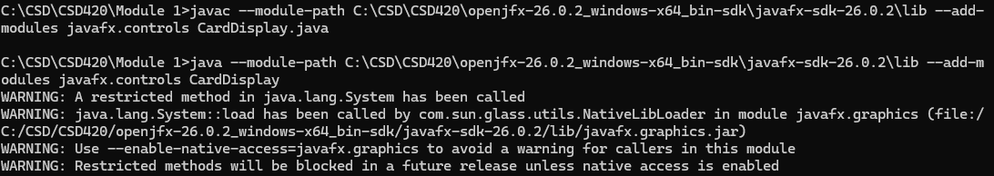
Figure 1: Successful javac compilation and java execution of CardDisplay.java

Screenshot 2: Java Version
The output of "java -version" confirms Java 26.0.1 is installed and available on the command line.
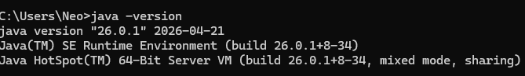
Figure 2: java -version output confirming the installed JDK

Screenshot 3: Application Window
The running CardDisplay application, launched from the compiled command shown above, is pictured below alongside the VS Code project. The window displays four randomly selected cards (3 of Spades, Ace of Diamonds, 8 of Spades, and 6 of Diamonds) and the New Hand button used to redraw the hand.
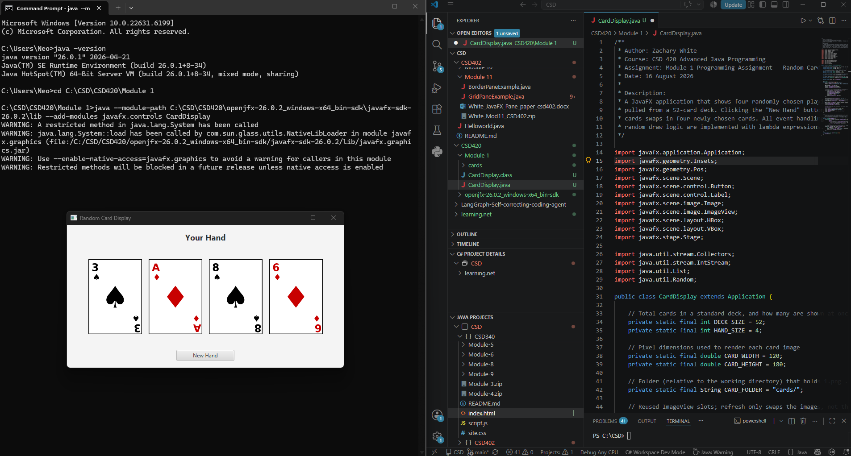
Figure 3: CardDisplay JavaFX application window showing a randomly dealt hand

